**Question 1.**

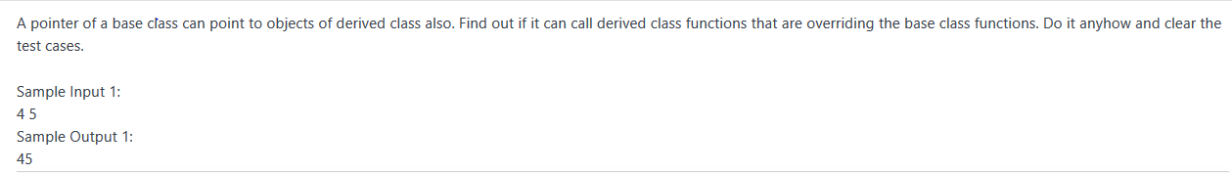

**Question 2.**

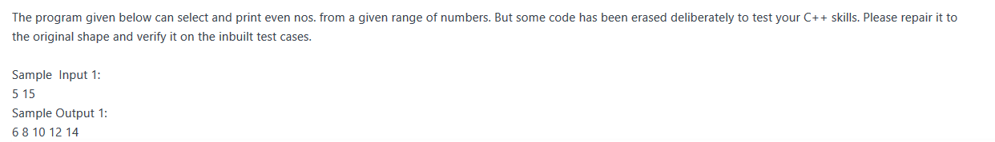

**Question 3.**

C:\Users\MANI\Pictures\Screenshots\Screenshot (5).png

**Question 4.**

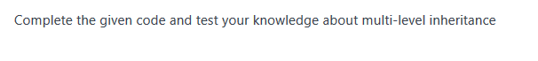

**Question 5.**

A class **bill** is inherited by two classes **cheque, cash** in **protected mode**.

**bill** class has two members **item_price,qty.**

The product of the two, 1. price of the item and 2. quantity will give us the **total bill**.

class **cheque** again has two members **cheque_no, cheque_amt**.

Write a member function to test whether the amount in the cheque clears the bill or not.

**if yes** put the word **"Clear" if no** put the balance amount as **"Balance=100" (100 is an example).**

**Similarly class cash** has 4 data members for the number of **notes of 500,100,10,1.**

**Total** is to be calculated from the notes and again **matched with the bill.**

If the bill is cleared with cash put the word **"Clear" if no** put the balance amount as **"Balance=100" (100 is an example).**

**Sample Input 1:**

1          // for cheque clearance

10        //item_price

10        //qty

1234    //cheque_no

80        // cheque_amt

**Sample Output 1:**

100                  //bill [item_price*qty]

Balance=20     //pending=100-80=20

**Sample Input 1:**

2          //for cash payment

10        //item_price

10        //qty

0          //notes of 500

0          //notes of 100

10        //notes of 10

0          //notes of 1

**Sample Output 1:**

Clear

**Question 6.**

A class **string1** allocates appropriate memory (using new operator) to a string

**passed from the main function**, and then decrypt the string, by subtracting 3 to

the ASCII value of each alphabet of the string.

**Sample Input:**

Deklodvkd

**Sample Output:**

Abhilasha

**Question 7-**

Given the following inheritance structure of classes that represents the student details, marks in 3 subjects and Result respectively, generate the sample output.

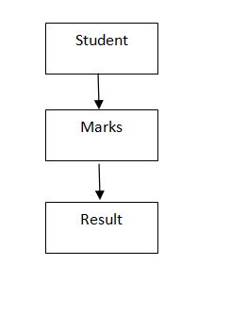

**Question 8-**

Write a program to enter basic information(name,empId,gender) and department information(dept name,assigned work,timetaken) for an employee and print the entire information using classes basicInfo, deptInfo  and employee classes.For Wrong values print "Wrong Input".

Constraint:

timetaken can't be zero or negative.

Sample Input:

rahul    //name  
101    //empID

m        //gender  
cse    //dept name  
dl    //assigned work  
45    //timetaken

**Question 9-**

 Write a program to calculate area of Square and Circle using classes Shape,Square and Circle.

Sample Input:

2

3

Sample Output:

Area of square: 4  
Area of circle: 28.26

Sample Output:

rahul  
101  
m  
cse  
dl  
4.5

**Question 10 –**

Write a program to calculate square and cube of a number N using classes Number,Square and Cube.

Constraint:

1<=N<=1000

Sample Input:

2

Sample Output:

Square of 2 is: 4  
Cube   of 2 is: 8

**Question 11-**

Write a program to calculate total result of a student by adding marks in two subjects and sports marks using classes Student,Sports,Test and Result.For wrong values print "Wrong Input".

Constraint:

all inputs are greater than 0

Sample Input:

2    //Roll Number  
3    // Marks in Sub 1  
4    //Marks in Sub 2

5    //Sports Marks

Sample Output:

Roll number 2  
Marks in sub1 3  
Marks in sub2 4  
Score 5  
total = 12

**Question 12-**

Write a program to calculate area of Square and Circle using classes Shape,Square and Circle.

Sample Input:

2

3

Sample Output:

Area of square: 4  
Area of circle: 28.26

**Question 13-**

Given the following inheritance structure of classes that represents the marks of one student in internal and external assessments of 3 subjects respectively and the Result class generates the rand total.

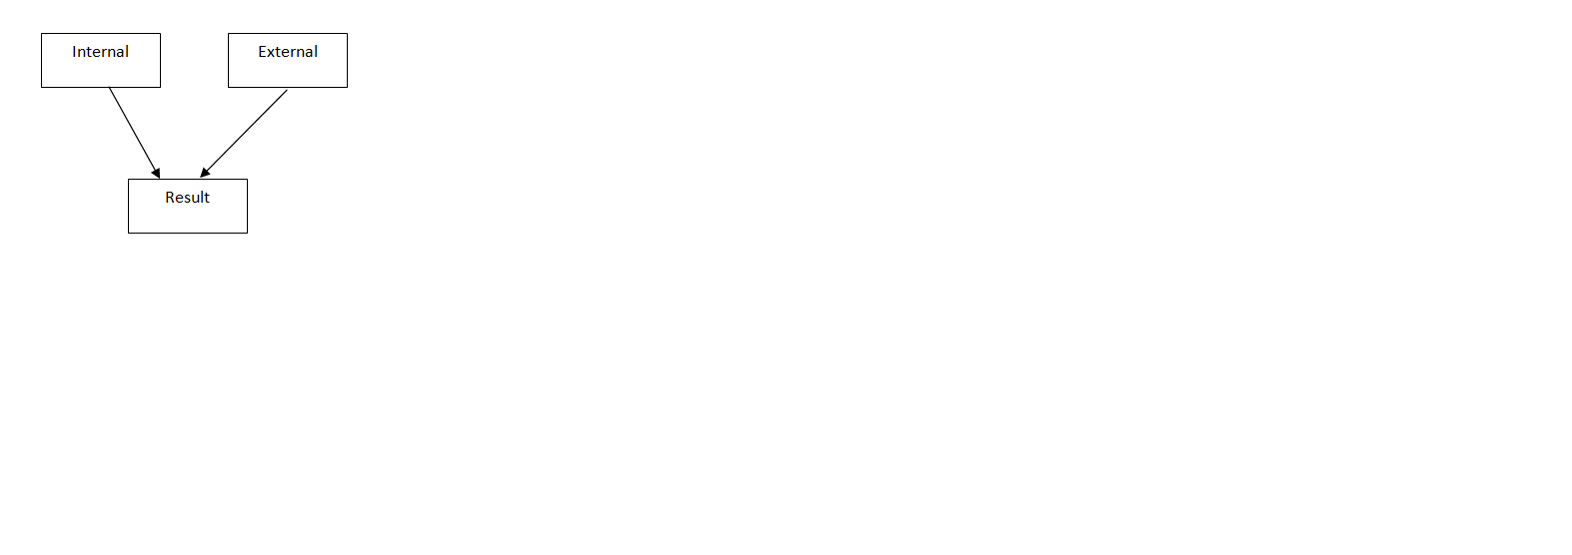

Sample Input:

12

34

56

10

20

30

Sample Output:

102

60

162

**Question 14-**

Base Class name bill has three data members: item_code, price, total.

Class cash is derived from bill having deno, value,  num and cheque is also derived from bill having chec_no,bank_name as data members.

The customer is having an option to buy from cheque or cash.

Sample Input:

//Number of items

5

//itemcodes and prices

1

10

2

10

3

10

4

10

5

10

//Option Cheque/cash

2

//Num of Denominations

3

//1st Denomination

Rs. 100

//value of 1st Denomination

2

//2nd Denomination

Rs. 50

//value of 2nd Denomination

2

//3rd Denomination

Rs. 10

//value of 3rd Denomination

2

Sample Output:

//Total

50

notes=3

100

2

50

2

10

2

**Question 15-**

employees of some particular bank want an application interface for performing cash transaction online so they have created an app . Create a class named employee with data members --account_no(long int), balance and member function void get_data() and void display_data().

Class beneficiary has data member- b_acc_no(long int) , b_bal and b_amt. member function of this class are void get_b_data() and void transfer() and void print().

transfer function is used to transfer amount from employee account to beneficiary account . If amount to be transferred is less than employee's balance then print "insufficient balance".

Sample input:

12345    //employee acc no

2000    //balance

19876    //beneficiary acc no

1000    // balance in beneficiary acc

500       // amount to be transferred

Sample output:

12345

1500        //500 deducted from employee

19876

1500        //500 added to beneficiary

**Question 16-**

Raj works in two shifts, (Shift1 and Shift2).For both shifts he maintain a  separate list of some size which contains the number of items he sold in one shift. At the end of day he adds  both the lists index wise. ( item1 in list1 will be added to item1 in list2). But the calculator on which he calculated has problem that when addition goes beyond 100 ,the value decremented by 100.Help raj to add two lists.

CONSTRAINT:

Array elements must be in range from 1 to 100(including 1 and 100)

If after addition the value becomes greater than 100, reduce the value by 100.(eg. 116 will result to 16).

Sample Input

4     //list size

input for list 1

78  
81  
12  
45

input for list 2  
38  
21  
67  
34

Sample output

16

2

79

79

**Question 17 -**

Define a class Customer with the following specifications.

Protected Members :

Customer_no integer

Customer_name char (20)

Qty integer

Price ,

Discount,

Netprice float

Member Functions: Public members: * A function Input( ) – to read data members(Customer_no, Customer_name, Quantity and Price)

create Another class Seller has member function Caldiscount(). * Caldiscount ( ) – To calculate Discount according to TotalPrice and NetPrice

TotalPrice = Price*Qty

**TotalPrice >=50000 – Discount 25% of TotalPrice**

**TotalPrice >=25000** **and TotalPrice <50000 - Discount 15% of TotalPrice**

**TotalPrice <250000 - Discount 10% of TotalPrice**

Netprice= TotalPrice-Discount

Show( ) – to display Customer details.

Sample input:

123                //customer_no

Ravi               //customer_name

10               //quantity

100            // Price

Sample output:

123

Ravi

10

100

1000      //total price=quantity*price

100       //discount

900       // Net-price

**Question 18-**

Create a class arradd which has an integer array as a data member.

Overload the + operator to **add two arradd type objects**and the result

of addition should be stored in the third object.

**Note: size of both the arrays is same and determined at run-time.**

**Sample Input:**

5                    //size of the arrays

1 2 3 4 5     //elements of first array

3 3 3 3 3     //elements of second array

**Sample Output:**

4    //result of addition

5    //of first and

6    //second array

7

8

Question 19-

Consider a class named Base having its data members as name and its roll number.A another class named Internal inherits this class in public mode and having its data members as 4 subject marks as internal.Their is an independent class named External having external marks of 4 subjects.The last class named Complete_Info being derived from External and Internal, calculates the total of internal marks obtained by student as well as sum of external marks and grand total.

Generate a code to display the name ,roll_no,sum of internal marks,sum of external marks, grand total and Grade of student. Grade can be calculated using following criteria.

| Total Marks | Grade |
| --- | --- |
| less than 40 | R |
| 41 to 60 | C |
| 61 -80 | B |
| 81-100 | A |

For Example

Input:

Raj

1

2

1

1

1

5

5

5

4

Output:

Raj 1 5 19 24 R

Explanation:

Input Contains

NAME OF  THE STUDENT

Raj

ROLL_NO

1

INTERNAL MARKS IN FOUR SUBJECTS

2

1

1

1

EXTERNAL MARKS IN FOUR SUBJECTS

5

5

5

4

Output contains

Name Roll_no Total _internal_ marks Total _external_ marks Total_marks Grade

Note: All elements in output are separated by space

**Question 20-**

In a multiple Inheritance Problem, **Base class1**(one) contains the information of first number

and **Base class2**(two) contains the information of second number.

**Derived Class**(last) inherited from both the base classes(one and two) gives the product of the first number and the second number.

***Sample Input:***

33    //first no

44    //second no

***Sample Output:***

33

44

1452    //product of two nos

**Question 21-**

Implement a class **employee** that inherits two classes**-(1) contract and (2) permanent.**

**The base class employee** contains the information of employee as: employee ID,name of the employee,designation of the employee.

**Derived class1 (contract**) contains information: no of working hours of employees, no of wages per hour and displays the salary of employee as the product of no of working hours and no of wages per hour

**Derived class2(permanent)** contains information: basic pay, HRA, TA and calculate its DA (10% of the basic salary), and displays the calculated salary(sum of basic,HRA,TA,DA).

Sample Input:

12    //employee ID

Priyanka    //employee name

Assistant Professor    //Designation of employee

12    //no of working hours

2000    //wages per hour

20000    //basic salary

800    //HRA

400    //TA

***Sample Output:***

12

Priyanka

Assistant Professor

24000    //salary of employee

43200    //calculated salary

**Question 22-**

We want to use class Result that has been derived from student class in **protected mode**.

The base class (student) will contain the information: roll no and course of student.

The derived class(result) contains the marks of three subjects and calculate the total of marks(sum of all the three subjects)

**Sample Input:**

23    //Roll No

CSE    //course of student

34    //marks of subject1

45    //marks of subject2

56    //marks of subject3

**Sample Output:**

23

CSE

135    //total marks of all the three subjects

**Question 23-**

Arjun is maintaining list of some words. Keith who is derived class of Arjun, aims at finding the string, which has maximum occurrences. Display the resultant string with its occurrence. If there is a tie between strings then calculating the ascii of complete string will act as tie breaker.

Input:

First line contains number N, that is number of strings and next N lines gives N strings. For example

3

hello

good

hello

Output:

String with frequency of occurrence of that string. For Example output of above input is

hello

2

Constraint:

(1 <= N <= 10)

(1<= String Size <=15.

**Question 24-**

Using the concept of inheritance, there is a base class which takes the lower bound and upper bound values and derived class takes the responsibility of finding the prime nos. between them (inclusive LB and UB values) and printing the digit which has the maximum frequency, if the multiple digits have same frequency, print the bigger digit as result ?

Sample Input Test Case 1:

3

10

Sample Output Test Case 1:

7

1

Explanation:

Sample Input Test Case 1:

Lower Bound and Upper Bound Values are given as input.

Sample Output Test case 1:

Between 3 and 10, the prime nos. are 3,5,7.  Occurrence for each digit is 1, therefore bigger digit is chosen as the result with its occurrence count.

Sample Input Test Case 2:

7

20

Sample Output Test Case 2:

1

5

Explanation:

Sample Input Test Case 2:

Lower Bound and Upper Bound Values are given as input.

Sample Output Test Case 2:

Between 7 and 20, the prime nos. are 7,11,13,17,19.  Occurrence for digit 7 is 2, for digit 1 is 5, for digit 3 is 1 and for 9 is 1. Therefore, the digit which has maximum occurrence frequency is 1. The digit is printed with its count value as the result.

**Question 25-**

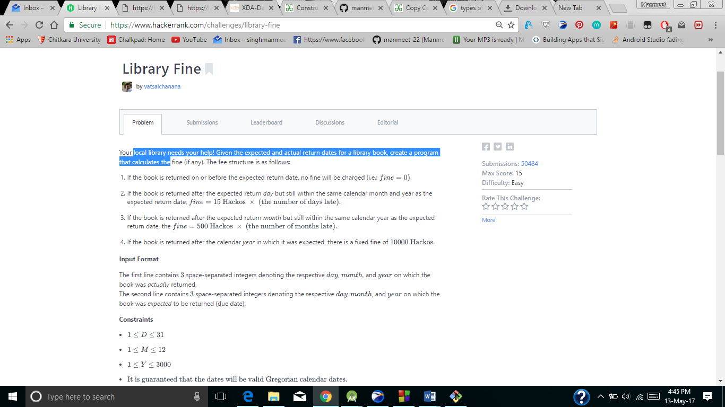

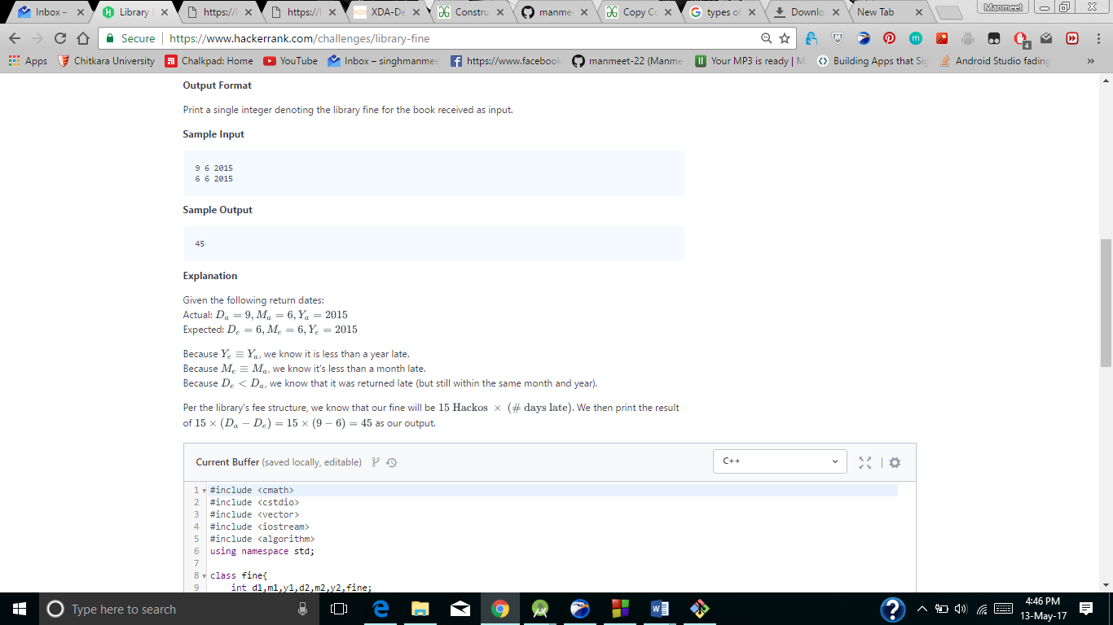

**Question 26-**

Write a program to sort an array (n=5) using Templates.

Sample Input:

10// First array

50

40

30

20

1.1//Second Array

5.5

3.3

4.4

2.2

Sample Output:

10 20 30 40 50

1.1 2.2 3.3 4.4 5.5

**Question 27 –**

Write a program to find whether or not a student is eligible for playing cricket in under 19 team.

A player is eligible only if his/her age is greater than equal to 13 or less than equal to 19.

Sample Input 1:

13

Sample Output 1:

Eligible

Sample Input 1:

-5

Sample Output 1:

Wrong input

**Question 28-**

You have been given three classes Book, Pages and Library.

Class Book that contains information of book like title

author, publisher, price. Enter this information using get() function and display that information using display() function.

Class Pages contains information of pages that will enter number of pages through get() and will display them through display() function.

Class Library is inheriting Book and Pages classes to display the record of a particular book whose title has been entered in the main() function. Complete the search function to search the information of given book title but if that title record doesn't exist

then print "NOT FOUND"

Complete the code by writing all the given function to find the record of given book

Title.

**Sample Input**

2

ProgrammingInC

ReemaThreja

Oxford

230

400

JavaProgramming

GarryCornHill

TataMcGrawHill

340

500

JavaProgramming

**Sample Output**

JavaProgramming

GarryCornHill

TataMcGrawHill

340

500

**Question 29-**

Neel got a task at school to collect N stones.He can collect only 1 stone a day. As N can be a very large number so it could take many days to complete the task, but then he remembers that his mother gave him a magic that can double anything (i.e if he has 2 stones, the magic will make them to 4 stones). Neel can use this magic any number of time on the collected stone on a particular day and add this to the previously collected stones. Remember that he wants exactly N stones and he can't throw any stone. If he gets more than N stones then he gets 0 marks, of course he doesn't want 0 marks. Help him to collect exactly N stones in minimum number of days.Create a base class problem and define it as abstract class and a derived class stones to solve neel’s problem.

**Sample Input**  
  
2  
1  
3  
  
**Sample Output**  
  
1  
2

**In the Sample Input**

First line of input will contain number of test cases (T). Then next T lines contains a single number N, which is number of stones Neel has to collect.

**In the Sample output**

 For each test case, Print a single number which is the minimum number of days taken by Neel to complete the task.

**Question 30-**

Customer visits a supermarket where he can pay either by cash or by cheque according to item code and price of items bought. Cash_Payment and Check_Payment are derived from base class Bill which contains item_code ,price of items and total .

 If user wants to pay by cash ,only total will be printed by doing sum of all prices of items bought.

 If user wants to pay be cheque, alongwith total, cheque number and bank name are also printed.

**Sample Input1**

5

1

2000

2

2000

3

3000

4

4000

5

5000

2

**Sample Output1**

TOTAL=16000

Sample Input 2:

3  
1  
5000  
2  
4000  
3  
9000  
1  
UCO  
987653222

Sample Output:

TOTAL=18000  
BANK NAME=UCO  
CHEQUE NUMBER=987653222

**Question 31-**

Create a class Shape inherited by two classes Sphere and Hemisphere. Shape class consists of virtual function. A class Loader is responsible for loading all the calculations in respective classes. Using these three classes, design a program that will accept dimensions of a Sphere and Hemisphere respectively and display the volumes respectively.

Sample Input:

3//radius

3//radius

Sample Output:

113.04//volume of Sphere  
6.28// volume of Hemisphere

**Question 32-**

Given a class hierarchy in which Parent is base class of Student ,Student is base class of Exam class.

Person contain data members as:

char name[100], char gender, int age.

Member functions as

void ReadData();

void DisplayData();

Student contain data members as:

int rollno, char branch[20]

Member functions as :

void ReadData();

void DisplayData();

Exam contain data members as:

int marks[3], int total;

Member functions as :

void ReadData();

void DisplayData(Exam[],int) //Will display sorted record of n students.

void SortMarksWise(Exam[],int); //Will sort data according to total of two subjects in descending order.

//Name has been entered without space.

Sample Input

3

RajKumar //Name

M //gender

24 //age

90 //rollno

CSE //branch

100 //marks of 1st subject

100 //marks of 2nd subject

100 //marks of 3rd subject

David

M

22

91

CSE

90

100

50

JohnDavid

M

24

92

ECE

92

50

50

Sample output

RajKumar M 24 90 CSE 300

David M 22 91 CSE 240

JohnDavid M 24 92 ECE 192

**Question 33-**

Joey wants to measure the area of props that he uses while playing his favourite games. Specifically, he enjoys playing Snakes and Ladders, and Beach Soccer. In Snakes and Ladders, he wants to measure the area of dice used and similarly in Beach Soccer, he wants to know the area of football used.

Area of dice=6*side*side

Area of football=4*pi*radius*radius

**Sample Input**

2

6

**Sample Output**

Area of dice used = 24

Area of Football used = 452.39

**Question 34-**

Create three classes Person, Professor and Student. The class Person should have data members name and age. The classes Professor and Student should inherit from the class Person.

The class Professor should have two integer members: publications and cur_id. There will be two member functions: getdata and putdata. The function getdata should get the input from the user: the name, age and publications of the professor. The function putdata should print the name, age, publications and the cur_id of the professor.

The class Student should have two data members: marks, which is an array of size 6 and cur_id. It has two member functions: getdata and putdata. The function getdata should get the input from the user: the name, age, and the marks of the student in 6 subjects. The function putdata should print the name, age, sum of the marks and the cur_id of the student.

For each object being created of the Professor or the Student class, sequential id's should be assigned to them starting from 1.

Solve this problem using virtual functions, constructors and static variables. You can create more data members if you want.

**Sample Input**  
  
4

1

Walter 56 99

2

Jesse 18 50 48 97 76 34 98

2

Pinkman 22 10 12 0 18 45 50

1

White 58 87  
  
**Sample Output**  
  
Walter 56 99 1

Jesse 18 403 1

Pinkman 22 135 2

White 58 87 2

**In the Sample Input**

There are two types of input. If the object being created is of the Professor class, you will have to input the name, age and publications of the professor.

If the object is of the Student class, you will have to input the name, age and the marks of the student in  6 subjects.

**In the Sample output**

 There are two types of output depending on the object.If the object is of type Professor, print the space separated name, age, publications and id on a new line.If the object is of the Student class, print the space separated name, age, the sum of the marks in 6 subjects and id on a new line.

**Question 35-**

Given two classes alpha and beta, create a new class gamma.

Features of 'gamma' class:

1. It should inherit the classes alpha and beta.
2. It should have a constructor gamma(int a, int b, float c).
3. Initialize members of alpha with '2 * a'.
4. Initialize all the members of beta with 'c'.
5. 'gamma' should have two member variables named u, v. 'u' should be initialized with 'a' and 'v' with 'b'.
6. It should contain a member function 'show_gamma()' defined below.

void show_gamma(){

   cout <<" u = "<<u<<"\n";

   cout <<" v = "<<v<<"\n";

}

**Note:**The beta constructor should be called before alpha constructor.

**Question 36-**

You are given two classes, *Person* and *Student*, where *Person* is the base class and *Student* is the derived class. Completed code for *Person* and a declaration for *Student* are provided for you in the editor. Observe that *Student* inherits all the properties of *Person*.

* A *Student* class constructor, which has 4 parameters:
  1. A string, firstName.
  2. A string, lastName.
  3. An integer, id.
  4. An integer array (or vector) of test scores, scores.

Complete the *Student* class by writing char calculate() method as given below specification:

* A *char calculate()* method that calculates a Student object's average and returns the grade character representative of their calculated average:

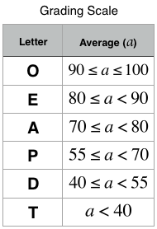

**Sample Input**

Heraldo Memelli 8135627

2

-100 80

**Sample Output**

 Name: Memelli, Heraldo

 ID: 8135627

 Grade: O

**Explanation**

In Sample Input

Heraldo Memelli is the name of student including first and last name.

8135627 is id of the student

2  stands for number of subjects

100 80 are marks of 2 subjecst

This student had 2 scores to average: 100 and 80. The student's average grade is (100+80)/2=90. An average grade of 90 corresponds to the letter grade O, so calculate*()* method should return the character 'O'.

**Question 37-**

Stack is a linear data structure which follows a particular order in which the operations are performed. The order may be LIFO (Last in First Out) or FILO (First in Last Out).

An abstract class “Stack” has been given from which you will design “Mystack” class to implement push () function to insert elements in stack, pop () function to pop () elements from stack and max () function to find maximum element from the stack.

The main () and max () function has been already defined in the unedited portion of the specified code. Your task is to complete push () function that will insert elements in stack and pop () function that will remove elements in opposite order from the stack.

Complete the given incomplete code to design stack implementation.

**Sample Input**

5

1 2 3 4 5

**Sample Output**

Max is 5

**Question 38-**

You have been given a task to create a class Area_Figure and a class CSquare ,and calculate the circumference and area of the figure where

     Surface is calculated as dSide*dSide   
    Circumference is  4.0*dSide  
     Side returns the value of dSide

Sample Input:

4.86  
5.11

Sample Output:

Surface=23.6196  
Circumference=19.44  
Surface=26.1121  
Circumference=20.44

Sample Input:

 2.22

1.98

Sample Output:

Surface=4.9284

Circumference=8.88

Surface=3.9204

Circumference=7.92

**Question 39-**

A class ‘Distance’ is used to model the distance measured in feet and inches. Among other operations it is required to add

a) two distance objects e.g. 3'6'' + 4' 9'' = 8' 3''         (12inches = 1 feet)

b) a value in meters  and a distance object, e.g. 3.5 + 4'9" = 8'3"

Input:

3 6 4 9 3.5

Output:

8 3

16 2

**Question 40-**

A class named ‘Rectangle’ is used to model rectangle objects. The data members and member functions of ‘Rectangle’ class are specified in the class definition. You are required to define the member functions outside the class using scope resolution operator.

**Question 41-**

**Question 42-**

**Question 43-**

**Question 44-**

**Question 45-**

**Question 46-**

**Question 47-**

**Question 48-**

**Question 49-**